 **Endodontics**

**Lec.4 د.فرح عبد الرزاق**

**Endodontic Instruments:**

There are many instruments used in the different phases of endodontic treatment and they are as follows:

**General Instruments**

**1) Endodontic explorer:** A double end instrument, one end is straight used to locate the root canal orifices after the removal of the pulp chamber, and the other end is L-shaped which aids in detecting the unremoved parts of the tooth as the roof of pulp chamber.

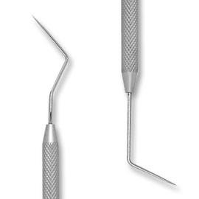

**2) Plastic instruments:** It has two ends; the first is used to carry temporary filling material. The opposite end is used as a plugger to condense cement and base materials in the root canal.

**3) Endodontic excavator:** It is larger than a spoon excavator, used to allow excavation of the contents of the pulp chamber. It is also used in curettage of periapical lesions in surgical endodontics (apicectomy).

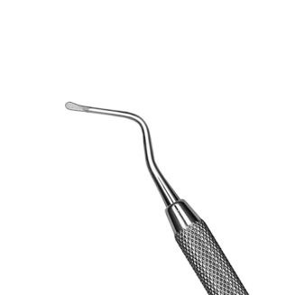

**4) Endodontic locking pliers (tweezer):** It has a lock that allows materials to be held without continuous finger pressure; also it has a groove which facilitates holding gutta percha and absorbing points.

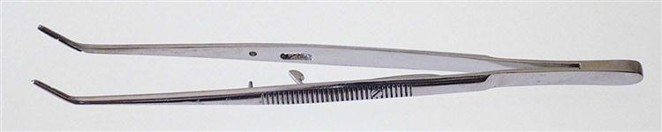

**5) Endodontic ruler:** It is a metal ruler made of 0.5mm divisions. It is a convenient instrument to measure reamers, files and gutta percha.

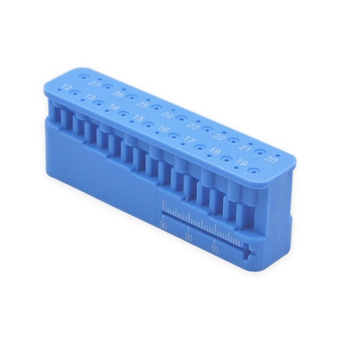

**6) Endodontic syringe:** It is used to carry irrigating solution into the root canal. The tip of the instrument is flat to prevent penetration of the needle to the small canals; also it has a groove in its tip to permit the irrigation which might be under pressure to flow coronally rather than forcing it to the apical foramen causing post-operative pain.

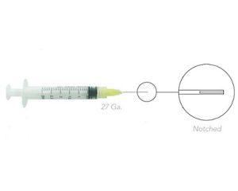

**7) Instrument organizer (endodontic kit):** It is used for arrangement of reamers and files according to the size and length. The organizer provides holes for the files to be place vertically in a sponge which is saturated with disinfectant to maintain its sterility.

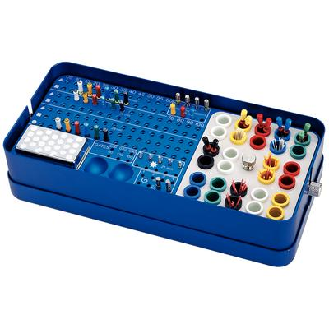

**8) Transfer sponge:** It is sponge saturated with disinfectant solution. The reamers and files can be placed in it after being used.

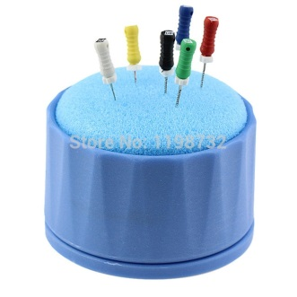

**9) Instrument stopper (rubber stopper):** It is used to mark the length of the tooth on reamers and files; it should be perpendicular to the long axis of the reamer. It may be made of rubber or metal.

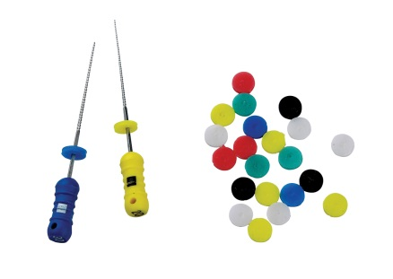

**Intracanal Instruments:**

These instruments are used inside the root canal.

**1) Barbed broach.**

This instrument is used inside the canal. It is a short handled instrument with a shaft having projections directed obliquely towards the handle. It is made of stainless steel, and used for pulp (vital pulp) extirpation, and removal of necrotic tooth debris inside the canal. It can be used to remove cotton and paper points from the canal. It is used in straight parts of the canal and inserted freely (by using the suitable size) to the 2/3 of the pulp canal; otherwise, fracture of the instrument may occur.

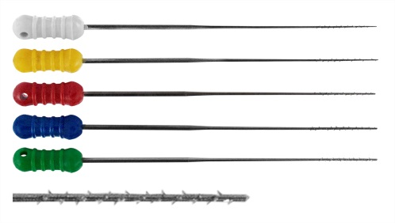

**2) K-Reamers and K-files.**

These instruments are made of stainless steel, because it is more flexible than carbon steel and don’t corrode, but nowadays, a super flexible material which is nickel-titanium is used. Reamers and files are manufactured by twisting a square bar to produce flutes but they differ in the number of flutes.

**(a) Reamers** are mostly used in reaming action and are less effective in filing action. Reamer = 0.5-1 flute/mm.

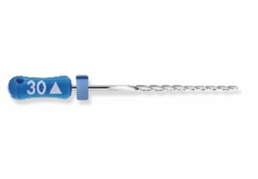 

**b)** **Files** are less flexible than reamers. It is mostly used in filing action but can be used in reaming action. K file = 1.5-2.25 flute/mm.

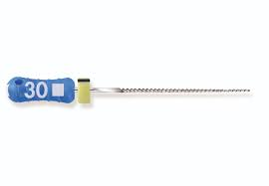 

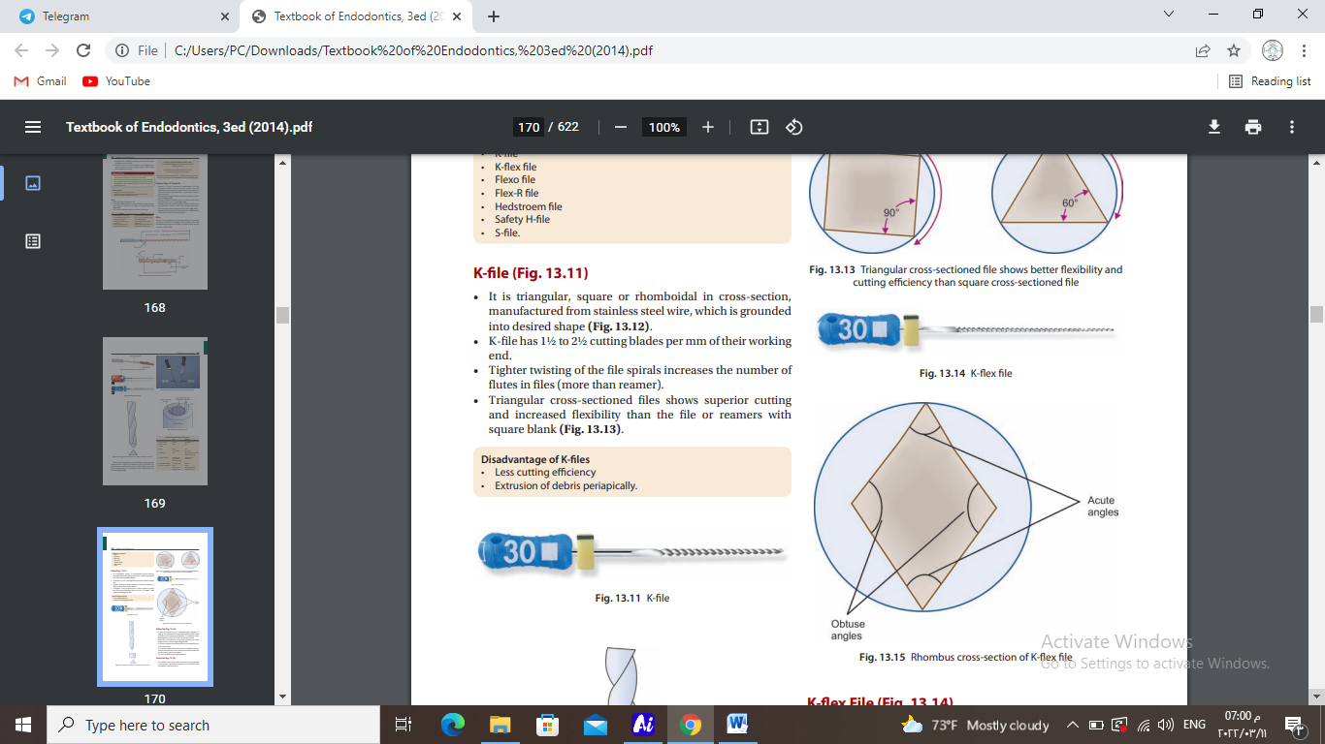**(c)** **K flex file:** It is a diamond cross section bar. It is more flexible and has sharper blades with non-cutting tip (blind tip).

**(d) Hedstorm files:** They are machined instrument that are made of stainless steel bar which are triangular in shape with very sharp edges. They are very active in just pulling action while K files are effective in both pulling and pushing action. It can not be used in rotation movement.

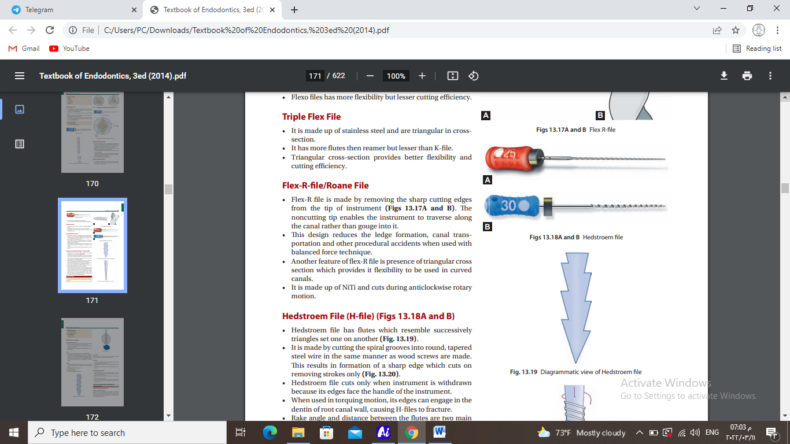

**Differences between reamers and files**

|  |  |
| --- | --- |
| **Reamer** | **File** |
| More flexible | Less flexible |
| Less number of cutting flutes | More number of cutting flutes |
| Used mainly in reaming action | Used mainly in filing action |
| Less effective in filing action because less no. of flutes. | Rotation Can be used in reaming action. |
| cutting motion is rotation and retraction | Push pull |
| Round preparation shape | Ovoid |

**Note: Triangular cross-sectioned files show superior cutting and increased flexibility than the file or reamers with square blank**

**3) Spreader:**

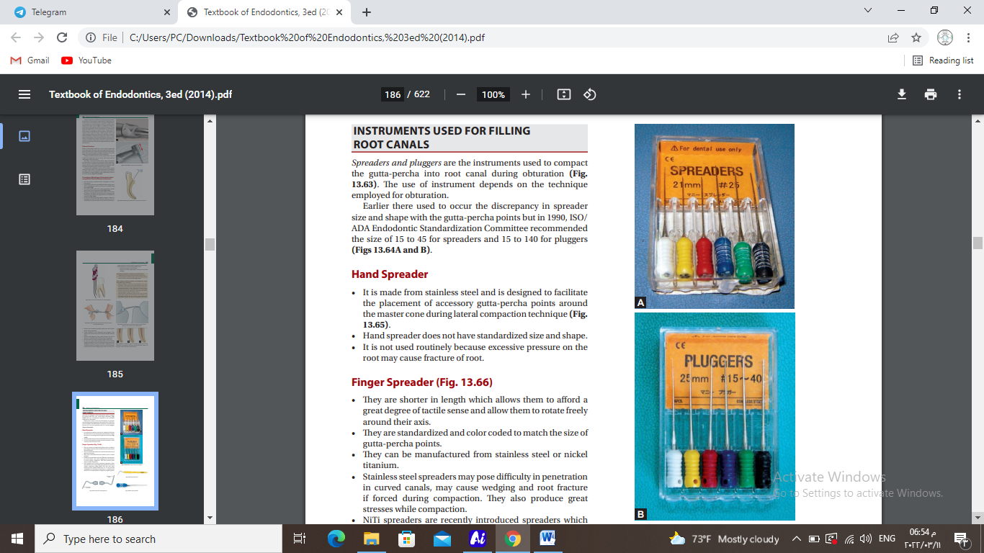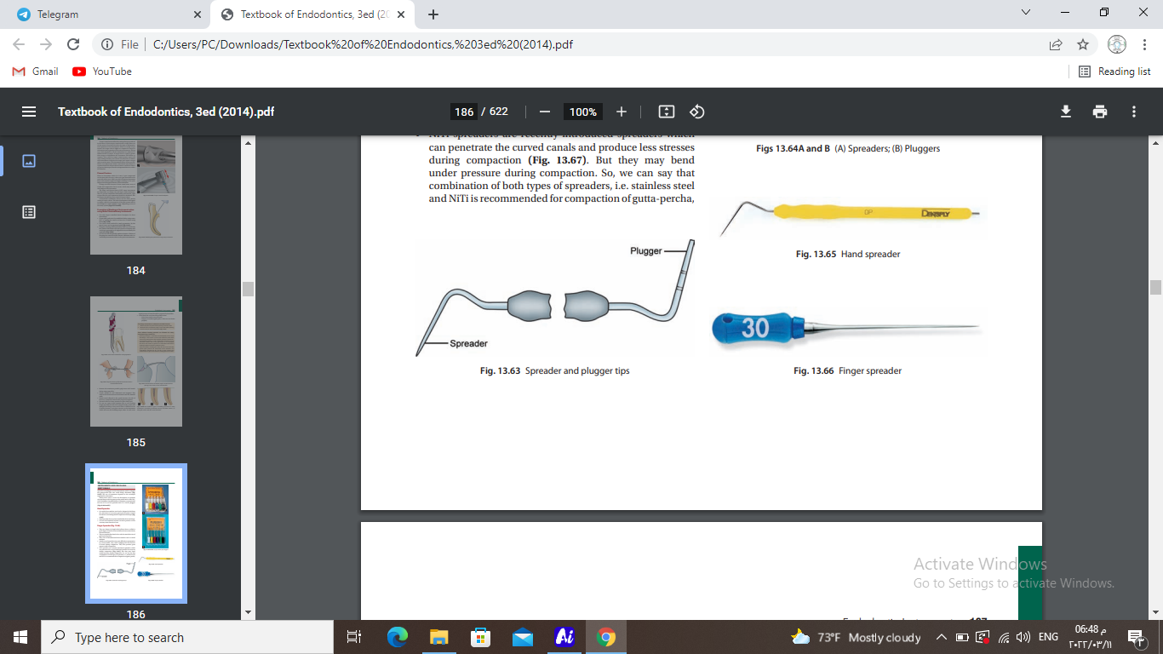It is a long, tapered and pointed end instrument, which is used to compress gutta percha into the apex and periphery of the prepared canal and also towards the irregularity of canals leaving a space for insertion of auxiliary root canal filling material cones. There is also a finger spreader and long handled which is smaller and shorter to be used in posterior teeth.

**4) Plugger**

It is a long and blunt flat tip blade instrument. It is necessary for vertical condensation technique and also plugging of gutta-percha at the termination of all other obturation condensation techniques. There are 2 types of pluggers, the long handled type and finger type.

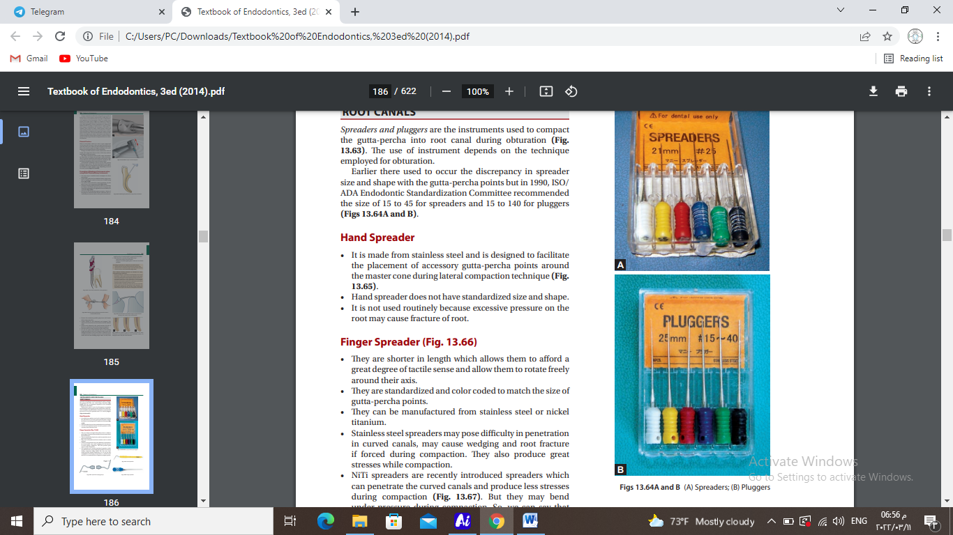

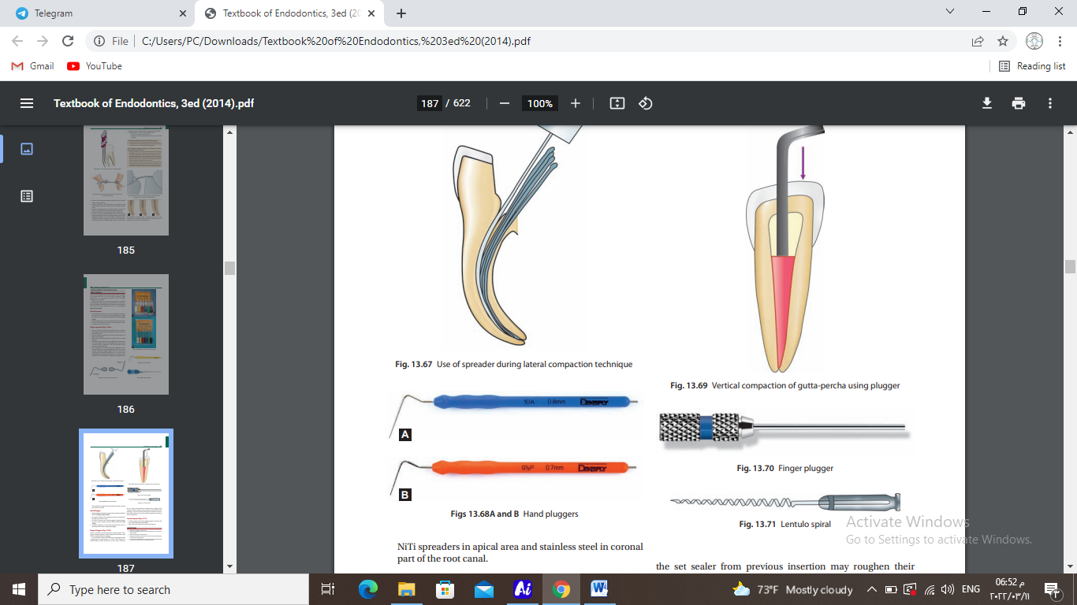



**Standardization of Intracanal Instruments:**

Each instrument has a number which refers to the size of its tip. The reamer of size 30 means that D0 = 0.3mm, while size 70 reamer means that D0 = 0.7mm.

D16 = D0 + 0.32 mm

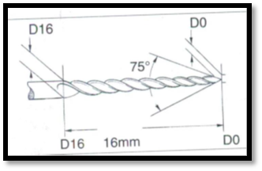So in size 50 reamer, the tip (D0) is 0.5 mm while D16 is 0.82 mm. The distance between D0 and D16 is 16mm, but the total length differs from short to medium to long for anterior teeth, and the shorter ones for posterior teeth.

All intracanal instruments are color coded and each color represents a size. Pink= 6, Gray= 8, Purple= 10, White= 15, Yellow= 20, Red= 25, Blue= 30, Green=35, Black= 40, then the colour returns to White= 45, and so on to Blue= 60 and then the instruments increase by 10 as Green=70, Black=80, and so onto size 140.

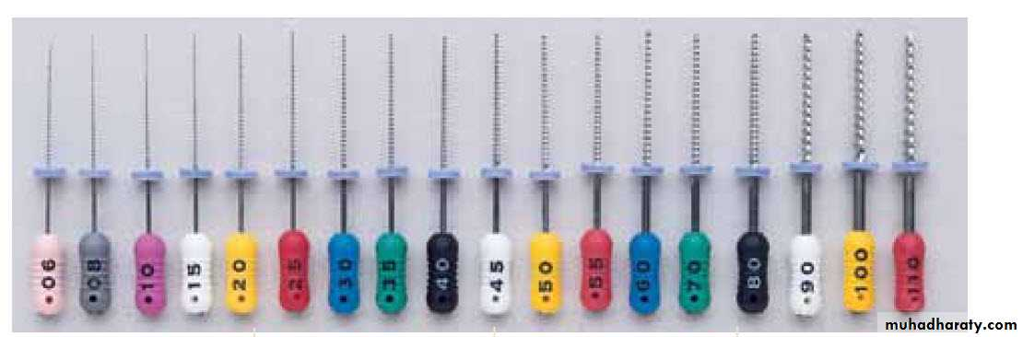

**Modes of action of Intracanal Instruments:**

**1) Reaming action:** It is a repeated clockwise rotation of the instrument which will shave the canal walls and give a cross sectional preparation approximately round. Reamers are usually more effective for this function.

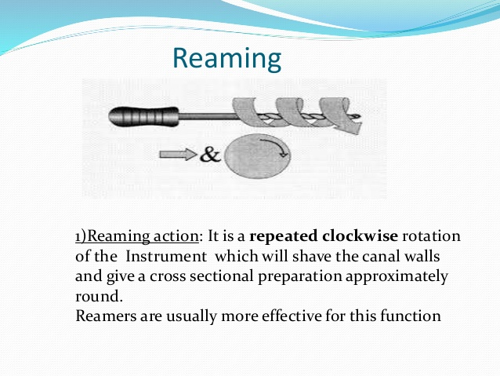

**2) Filing action:** It is a push-pull action without rotation which has a great efficiency with files than reamers. The cross sectional appearance of the prepared root canal is irregular with general oval configuration, so the canal must be filled with gutta percha.



**3) Quarter-turn filing:** This action is a combination of reaming and filing action. The instrument is inserted in the root with a quarter turn rotation (90o) then moved with dragging motion to produce an oval cross section. K-file and reamer can be used.



**4) Circumferential filing:** in this action, filing or quarter turn filing action is used with emphasis placed on the out stroke, so the file is dragged along different sides of the canal wall with each withdrawal. The resultant canal has a wide orifice with greater taper.